**PHIẾU BÀI TẬP TIẾNG ANH KHỐI 4 _ TUẦN 23**

1. Look,read and write **yes** or **no**

|  |  |  |
| --- | --- | --- |
|  | * She’d like some rice. * She’d like some meat. * She’d like some vegetables. * She’d like a cucumber. * She’d like some noodles. * She’d like some fish. * She’d like some water. * She’d like some bread. * She’d like an onion. * She’d like some cereal. | No  *………*  *………*  *………*  *………*  *………*  *………*  *………*  *………*  *………* |

1. **Look and write the words**
2. 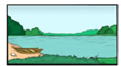 **2. **

**________ _______________**

**3.**  **4. **

**____________ ________________**

**5.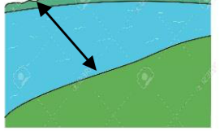 6. 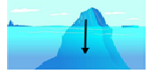 7.** 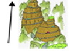

**_____________ _______________ ______________**

1. **Coppy the words two lines**
2. *lake (hồ)*

*………………………………………………………………………………………………………………………………………………………………………………………………………………………..*

1. *waterfall (thác nước)*

*………………………………………………………………………………………………………………………………………………………………………………………………………………………..*

1. *mountain (núi)*

*………………………………………………………………………………………………………………………………………………………………………………………………………………………..*

1. *ocean (đại dương)*

*………………………………………………………………………………………………………………………………………………………………………………………………………………………….*

1. *wide (rộng)*

*………………………………………………………………………………………………………………………………………………………………………………………………………………………..*

1. *deep (sâu)*

*………………………………………………………………………………………………………………………………………………………………………………………………………………………….*

1. *high (cao)*

*…………………………………………………………………………………………………………………………………………………………………………………………………………………………*